**Index**

|  |  |  |
| --- | --- | --- |
| **Sr No.** | **Content** | **Page No.** |
| Phase-1 | Preliminary Learning   * Group Details * Project Title * Project Domain * Project Definition | 1 |
| Phase-2 | Core Learning   * Project Overview * Detail Explanation * Advantages * Challenges * Output screens & * functionalities | 3 |
| Phase-3 | Inference Learning   * Real Life Application * Conclusion * Future Enhancement * References | 6 |

**Preliminary Learning**

**Group Details:**

**Team Members**:

* 23BCA56029 Parmar Manav

**Guide :**

* Dr. Darshna Patel

**Project Title**

* **Title**: Gamer’s Profile

**Project Domain**

* **Domain**: Web Development / Gaming Community

**Project Definition**

* **Objective**: - The Gamer's Profile is a web-based platform designed to allow gamers to create profiles, manage their gaming achievements, participate in tournaments, and engage with the gaming community.
* **Scope**:

o User authentication system

o Game catalog with images and details

o Community post functionality

o Responsive UI/UX

o Mobile-friendly design

o Admin panel for managing games, players, and tournaments

**Core Learning**

**Project Overview**

* **Technology Stack**:
  + Frontend: HTML, CSS
  + Backend: PHP
  + Database: MySQL
* **User Roles**:
  + Registered Users: can create an manage their profiles
  + Admin: Manage games content, handle user accounts, manage tournaments.

**Detailed Explanation**

**Features:**

User Authentication:

o Secure login and registration system

o User role management (Registered Users and Admin)

**Specific Game Profile:**

o Dynamic game listings with images

o specific game profile for each game

**Community Post**:

o Users can post their achievements with images and descriptions

o Posts are displayed in a community section to other player

**Tournaments Update**:

o List of tournaments with details and images

o Admins can add, update, or remove tournaments

**Database Management**:

oMySQL database storing user data, game details, player profiles, and tournaments

o Efficient indexing for fast queries

**Admin Panel**:

o Dashboard with statistics

o Add, remove, and update games

o Add, remove, and update players

o Add, remove, and update tournaments

**Advantages**

* Centralized platform for gamers to manage their profiles.
* Encourages community engagement and collaboration.
* Easy management of tournaments and gaming events.
* User-friendly interface with responsive design.

**Challenges**

* Ensuring data security and user privacy.
* Handling large amounts of data efficiently.
* Providing a seamless user experience across devices.
* Managing file uploads and storage for images and videos.

**Inference Learning**

**Real-Life Applications**

* Used by gaming communities to manage player profiles and tournaments.
* Can be extended to eSports organizations for managing professional players.
* Useful for gaming enthusiasts to connect and share their achievements.

**Conclusion**

* The Gamer's Profile successfully provides a platform for gamers to showcase their skills, connect with others, and participate in tournaments. It bridges the gap between casual and professional gaming communities.

**Future Enhancement**

* Integrating social media sharing for profiles and achievements.
* Implementing advanced analytics for player performance
* Introducing a mobile app for better accessibility.

**References**

* PHP and MySQL documentation
* Google Drive API for video embedding
* Web development best practices
* Security guidelines for web applications

**Pages Previews**

**Login Page**

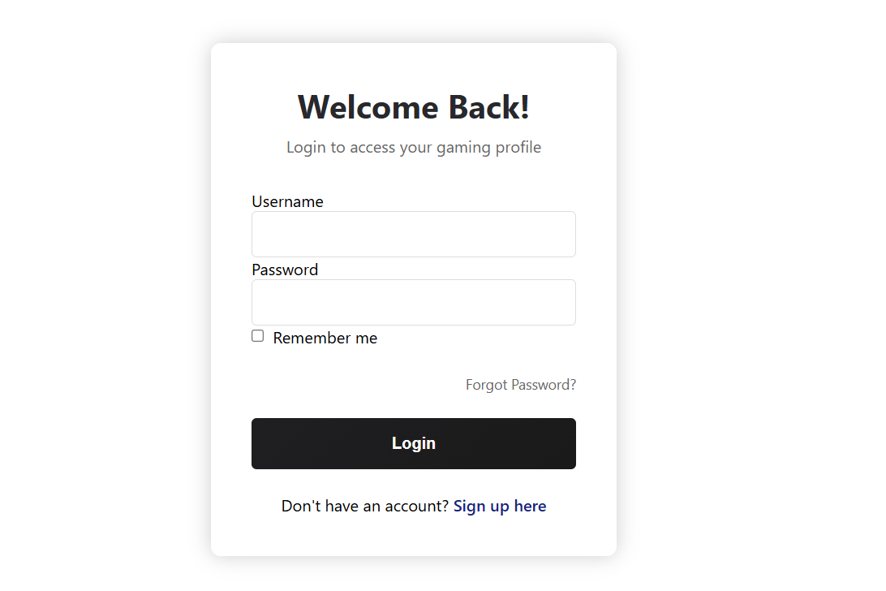

# **Email Field:** Enter your registered email.

# **Password Field:** Input your password to log in.

# **Login Button:** Submits the login credentials to access the admin panel.

**Home Page**

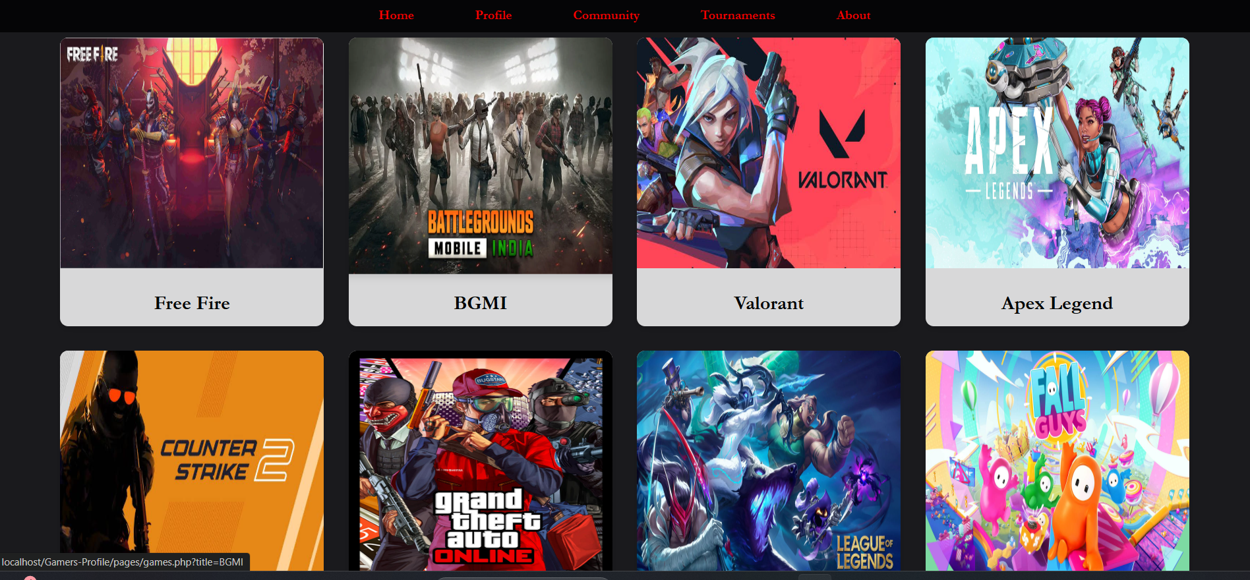

**Home Page**

* + Features a visually appealing video background showcasing gaming highlights.
  + Displays a list of games available on the platform with quick links to explore each game's details.
  + Includes a navigation bar for easy access to Profile, Community, Tournaments, and Login/Signup.

**Create Profile Page**

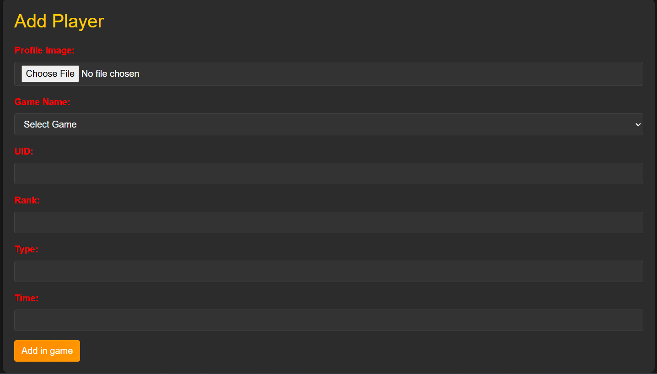

**Create Profile Page**

* + Add Player: Users can add their profile image to a specific game with details like UID, Rank, Type, and Time.

**Tournament Page**



**Tournament Page**

* + Lists tournaments with details and images.
  + Admins can manage tournaments by adding, updating, or removing them.

**Community Posts**

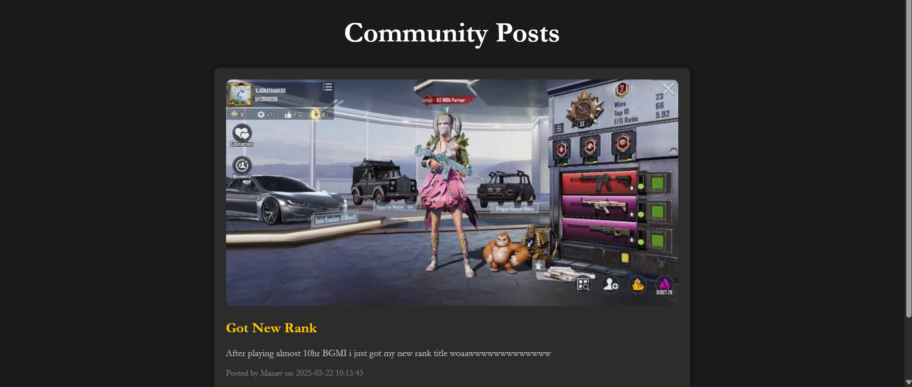

**Community Posts**

* + Players can add their achievements and express themselves through posts with images and descriptions.

**Manage Games**

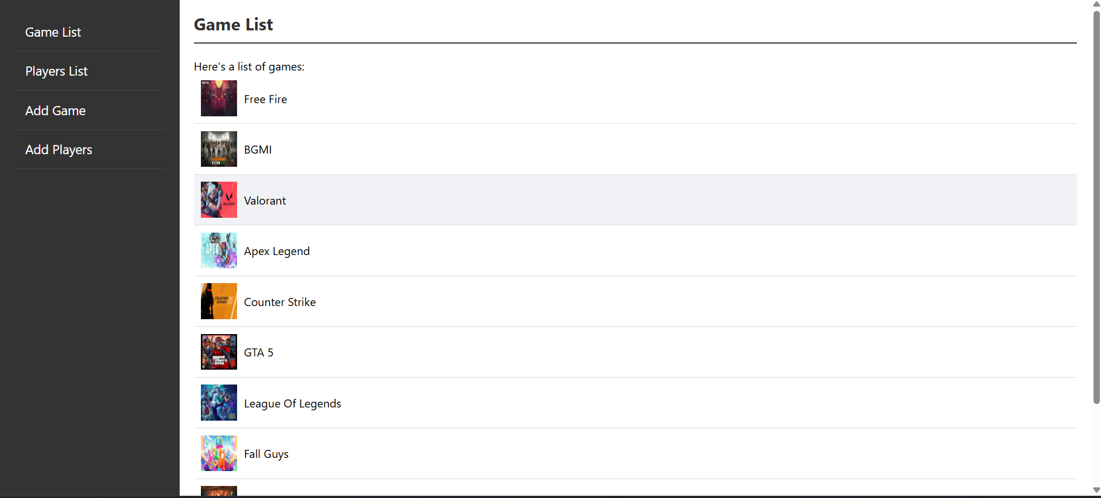

**Manage Games**

* + Game List: Lists all game names with images.
  + Player List: Lists all players with their details.
  + Add Game: Admins can add new games to the homepage.
  + Add Tournament: Admins can add new tournaments to the platform.

|  |  |  |  |  |  |
| --- | --- | --- | --- | --- | --- |
| Sr No | Column Name | DataType | Size | Constraints | Description |
| 1 | id | INT | 11 | Primary Key, Auto Increment | Unique identifier for the game |
| 2 | title | VARCHAR | 255 | Not Null | Title of the game |
| 3 | image | VARCHAR | 255 | Not Null | Path to the game image |

|  |  |  |  |  |  |  |  |  |  |  |  |  |  |  |  |  |  |  |  |  |  |  |  |  |  |  |  |  |  |  |  |  |  |  |  |  |  |  |  |  |  |  |  |  |  |  |  |  |
| --- | --- | --- | --- | --- | --- | --- | --- | --- | --- | --- | --- | --- | --- | --- | --- | --- | --- | --- | --- | --- | --- | --- | --- | --- | --- | --- | --- | --- | --- | --- | --- | --- | --- | --- | --- | --- | --- | --- | --- | --- | --- | --- | --- | --- | --- | --- | --- | --- |
| |  |  |  |  |  |  | | --- | --- | --- | --- | --- | --- | | **Sr No** | **Column Name** | **DataType** | **Size** | **Constraints** | **Description** | | 1 | player_id | INT | 11 | Primary Key, Auto Increment | Unique identifier for the player | | 2 | profile_image | VARCHAR | 255 | Not Null | Path to the player's profile image | | 3 | game_id | INT | 11 | Foreign Key | ID of the game played | | 4 | uid | VARCHAR | 255 | Not Null | User identifier | | 5 | rank | VARCHAR | 255 | Not Null | Player's rank in the game | | 6 | type | VARCHAR | 255 | Not Null | Type of player | | 7 | time | VARCHAR | 255 | Not Null | Time-related information | |

|  |  |  |  |  |  |
| --- | --- | --- | --- | --- | --- |
| **Sr No** | **Column Name** | **DataType** | **Size** | **Constraints** | **Description** |
| 1 | id | INT | 11 | Primary Key, Auto Increment | Unique identifier for the tournament |
| 2 | title | VARCHAR | 150 | Not Null | Title of the tournament |
| 3 | description | VARCHAR | 1000 | Not Null | Description of the tournament |
| 4 | organizer | INT | 150 | Not Null | Identifier of the organizer |
| 5 | created_at | VARCHAR | 150 | Not Null | Creation timestamp |
| 6 | photo | VARCHAR | 255 |  | Path to the tournament photo |

|  |  |  |  |  |  |
| --- | --- | --- | --- | --- | --- |
| Sr No | Column Name | DataType | Size | Constraints | Description |
| 1 | user_id | INT | 11 | Primary Key, Auto Increment | Unique identifier for the user |
| 2 | username | VARCHAR | 150 | Not Null | Username of the user |
| 3 | email | VARCHAR | 150 | Not Null | Email of the user |
| 4 | password | VARCHAR | 150 | Not Null | Password of the user |

|  |  |  |  |  |  |
| --- | --- | --- | --- | --- | --- |
| **Sr No** | **Column Name** | **DataType** | **Size** | **Constraints** | **Description** |
| 1 | id | INT | 11 | Primary Key, Auto Increment | Unique identifier for the post |
| 2 | title | VARCHAR | 255 | Not Null | Title of the community post |
| 3 | content | TEXT | - | Not Null | Content of the post |
| 4 | author | VARCHAR | 100 | Not Null | Author of the post |
| 5 | image | VARCHAR | 255 |  | Path to the post image |
| 6 | created_at | TIMESTAMP | - | Not Null, Default: current_timestamp | Timestamp of creation |

|  |  |  |  |  |  |
| --- | --- | --- | --- | --- | --- |
| Sr No | Column Name | DataType | Size | Constraints | Description |
| 1 | username | VARCHAR | 100 | Primary Key | Username for login |
| 2 | password | INT | 150 | Not Null | Password for the user |